**MODULE: 1**

* **Practical-1: Install JDK, setup Java environment and write a program to print-**

**“CODING IS FUN, ENJOY IT!”.**

// Install JDK

public class one {

public static void main(String[] args) {

System.out.println("\nCODING IS FUN, ENJOY IT!\n");

}

}

**> Output:**



* **Practical- 2: Write a program in Java to generate first n prime numbers.**

// Generate first n Prime Number

import java.util.Scanner;

public class two{

public static void main (String[]args){

Scanner sc = new Scanner(System.in);

int count = 0, n = 0, i = 1, j = 1;

System.out.print("Enter number of prime numbers to be printed: ");

int a = sc.nextInt();

while (n < a)

{

j = 1;

count = 0;

while (j <= i)

{

if (i % j == 0)

count++;

j++;

}

if (count == 2)

{

System.out.printf ("%d ", i);

n++;

}

i++;

}

}

}

**> Output:**



* **Practical- 3: Write a program to enter two numbers and perform all arithmetic, comparison, logical and bitwise operations on them.**

// Arithmetic, Comparison, Bitwise Operations

import java.util.Scanner;

public class three {

public static void main(String[] args) {

Scanner sc = new Scanner(System.in);

System.out.print("Enter first number: ");

int a = sc.nextInt();

System.out.print("Enter second number: ");

int b = sc.nextInt();

//Arithmetic Operations

System.out.println("\nAddition: " + (a + b));

System.out.println("Multiplication: " + (a * b));

System.out.println("Subtraction: " + (a - b));

System.out.println("Division: " + (a / b));

System.out.println("Modulus: " + (a % b));

System.out.println("Exponation: " + (a ^ b));

//Comparision Operations

System.out.println("\nGreater than: " + (a > b));

System.out.println("Greater than or equals to: " + (a >= b));

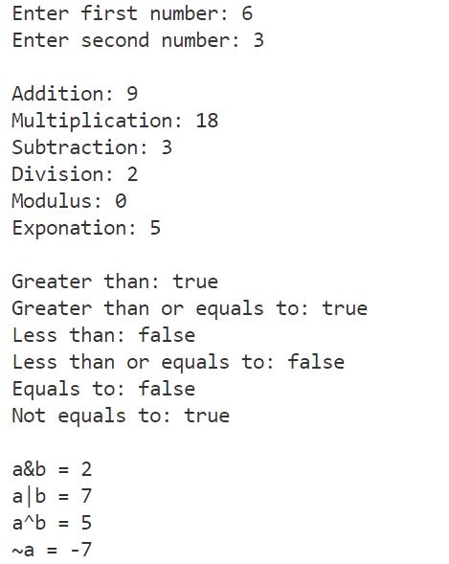 System.out.println("Less than: " + (a < b));

System.out.println("Less than or equals to: " + (a <= b));

System.out.println("Equals to: " + (a == b));

System.out.println("Not equals to: " + (a != b));

//Bitwise Operations

System.out.println("\na&b = " + (a & b));

System.out.println("a|b = " + (a | b));

System.out.println("a^b = " + (a ^ b));

System.out.println("~a = " + ~a);

}

}

* **Practical- 4: Write a program that scans marks and credits of 2 subjects of the student and Calculate: Grade of each subject (using else if ladder), Gradepoint of each subject from grade (using switch case), SPI using gradepoints and credits of 2 subjects.**

// Calculating Grade & SPI

import java.util.Scanner;

public class four {

public static void main(String[] args) {

Scanner sc = new Scanner(System.in);

//Calculating grade, gradepoints and SPI

String grade1, grade2;

int gradepoints1, gradepoints2;

//Inputing marks and credits of first subject

System.out.print("\nEnter marks of first subject: ");

int m1 = sc.nextInt();

System.out.print("Enter credits of first subject: ");

int c1 = sc.nextInt();

//Inputing marks and credits of second subject

System.out.print("\nEnter marks of second subject: ");

int m2 = sc.nextInt();

System.out.print("Enter credits of second subject: ");

int c2 = sc.nextInt();

//Calculating grades of first subject

if(m1 >= 80){

grade1 = "O";

}

else if(m1 >= 70){

grade1 = "A+";

}

else if(m1 >= 60){

grade1 = "A";

}

else if(m1 >= 55){

grade1 = "B+";

}

else if(m1 >= 50){

grade1 = "B";

}

else if(m1 >= 45){

grade1 = "C";

}

else if(m1 >= 40){

grade1 = "P";

}

else {

grade1 = "F";

}

//Calculating grades of second subject

if(m2 >= 80){

grade2 = "O";

}

else if(m2 >= 70){

grade2 = "A+";

}

else if(m2 >= 60){

grade2 = "A";

}

else if(m2 >= 55){

grade2 = "B+";

}

else if(m2 >= 50){

grade2 = "B";

}

else if(m2 >= 45){

grade2 = "C";

}

else if(m2 >= 40){

grade2 = "P";

}

else {

grade2 = "F";

}

//Calculating gradepoints of first subject

switch(grade1){

case "O":

gradepoints1 = 10;

break;

case "A+":

gradepoints1 = 9;

break;

case "A":

gradepoints1 = 8;

break;

case "B+":

gradepoints1 = 7;

break;

case "B":

gradepoints1 = 6;

break;

case "C":

gradepoints1 = 5;

break;

case "P":

gradepoints1 = 4;

break;

default:

gradepoints1 = 0;

break;

}

switch(grade2){

case "O":

gradepoints2 = 10;

break;

case "A+":

gradepoints2 = 9;

break;

case "A":

gradepoints2 = 8;

break;

case "B+":

gradepoints2 = 7;

break;

case "B":

gradepoints2 = 6;

break;

case "C":

gradepoints2 = 5;

break;

case "P":

gradepoints2 = 4;

break;

default:

gradepoints2 = 0;

break;

}

float spi = (float)((c1 * gradepoints1) + (c2 * gradepoints2)) / (c1 + c2);

System.out.println("\nGrade of first subject is " + grade1);

System.out.println("Gradepoint of first subject is " + gradepoints1);

System.out.println("Grade of second subject is " + grade2);

System.out.println("Gradepoint of second subject is " + gradepoints2);

System.out.println("SPI is " + spi);

}

}

**> Output:**

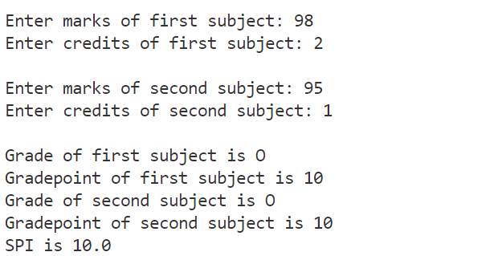

* **Practical- 5: Write a program in Java to find maximum of three numbers using nested if-else and conditional operator.**

// Maximum of Three

import java.util.Scanner;

public class five {

public static void main(String[] args) {

Scanner sc = new Scanner(System.in);

//Finding maximum of three numbers

System.out.print("Enter first number: ");

int a = sc.nextInt();

System.out.print("Enter second number: ");

int b = sc.nextInt();

System.out.print("Enter third number: ");

int c = sc.nextInt();

if(a > b){

if(a > c){

System.out.println(a + " is the greatest number");

}

else{

System.out.println(c + " is the greatest number");

}

}

else{

if(c > b){

System.out.println(c + " is the greatest number");

}

else{

System.out.println(b + " is the greatest number");

}

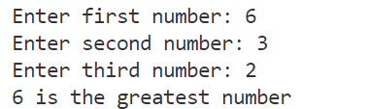 }

}

}

* **Practical- 6: Write a program to accept a line and check how many consonants and vowels are there in line.**

// Checking number of Consonants & Vowels

import java.util.Scanner;

public class six {

public static void main(String[] args) {

Scanner sc = new Scanner(System.in);

//Counting vowels and consonants in a line

System.out.print("Enter a string: ");

String s = sc.nextLine();

int vowel = 0;

int space = 0;

for(int i = 0; i < s.length(); i ++){

char letter = s.charAt(i);

if(letter == 'a' || letter == 'e' || letter == 'i' || letter == 'o' || letter == 'u'){

vowel = vowel + 1;

}

else if(letter == ' '){

space ++;

}

}

int conso = s.length() - vowel - space;

System.out.println("Number of vowels are " + vowel);

System.out.println("Number of consonants are " + conso);  
 }

}

**> Output:**

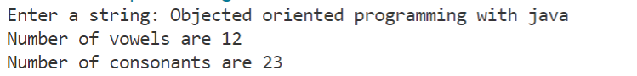

* **Practical- 7: Write a program to count the number of words that start with capital letters.**

// Number of words that start with capital letter

import java.util.Scanner;

public class seven {

public static void main(String[] args) {

Scanner sc = new Scanner(System.in);

//Counting number of words that start with capital letters

System.out.print("Enter a sentence: ");

String line = sc.nextLine();

int word = 0;

char firstletter = line.charAt(0);

if(firstletter >= 65 && firstletter <= 90){

word ++;

}

for(int i = 0; i < line.length(); i ++){

char letter = line.charAt(i);

if(letter == ' '){

char first = line.charAt(i + 1);

if(first >= 65 && first <= 90){

word ++;

}

}

}

System.out.println("Total words starting with capital letters are " + word);

}

}

**> Output:**



* **Practical- 8: Create a class which ask the user to enter a sentence, and it should display count of each vowel type in the sentence. The program should continue till user enters a word “quit”. Display the total count of each vowel for all sentences.**

import java.util.Scanner;

public class CountVowels {

public static void main(String[] args) {

Scanner sc = new Scanner(System.in);

String x = "yes";

while (x.equals("yes")){

System.out.print("Enter a sentence: ");

String str = sc.nextLine();

String s = str.toLowerCase();

int n = s.length();

int a=0, e=0, i=0, o=0, u=0;

for (int j=0;j<n;j++){

char letter = s.charAt(j);

if(letter == 'a' ){

a++;

}

if(letter == 'e' ){

e++;

}

if(letter == 'i' ){

i++;

}

if(letter == 'o' ){

o++;

}

if(letter == 'u' ){

u++;

}

}

System.out.println("Number of 'a': " + a);

System.out.println("Number of 'e': " + e);

System.out.println("Number of 'i': " + i);

System.out.println("Number of 'o': " + o);

System.out.println("Number of 'u': " + u);

System.out.println("Do you want to continue?");

x = sc.nextLine();

}

System.out.println("Thankyou! for your Time");

sc.close();

}

}

**> Output:**

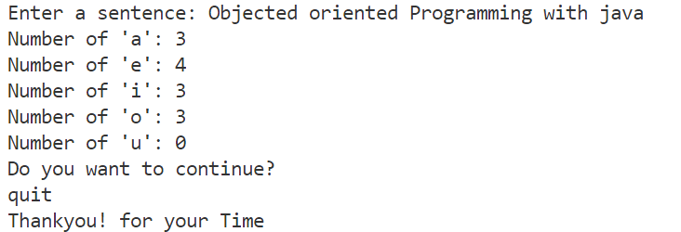

* **Practical- 9: Write an interactive program to print a string entered in a pyramid form. For instance, the string “stream” has to be displayed as follows:**

**S**

**S t**

**S t r**

**S t r e**

**S t r e a**

**S t r e a m**

// String in Pyramid form

import java.util.*;

class Pyramid

{

public static void main(String[] m)

{

char c;

int i,j;

Scanner in= new Scanner(System.in);

String s;

System.out.println("Enter A string : ");

s=in.next();

int k,d;

for(i=0;i<s.length();i++){

for(k=0;k<s.length()-i;k++) {

System.out.print(" ");

}

for(j=0;j<=i;j++){

c=s.charAt(j);

System.out.print(c+" ");

}

System.out.println(" ");

}

}

}

**> Output:**

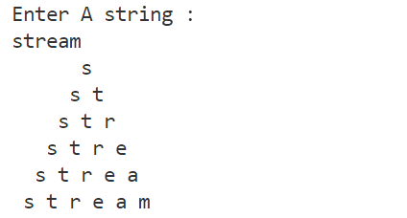

* **Practical- 10: Write an interactive program to print a diamond shape. For example, if user enters the number 3, the diamond will be as follows:**

**\***

**\* \***

**\* * \***

**\* \***

**\***

// Diamond Pattern

import java.util.Scanner;

public class Diamond {

public static void main(String[] args) {

Scanner sc = new Scanner(System.in);

int n = sc.nextInt();

for (int i=1; i<=n; i++){

for (int j=n-i; j>0; j--){

System.out.print(" ");

}

for (int k=1; k<=i; k++){

System.out.print("* ");

}

System.out.println();

}

for (int i=1; i<=n; i++){

for (int k=1; k<=i; k++){

System.out.print(" ");

}

for (int j=n-i; j>0; j--){

System.out.print("* ");

}

System.out.println();

}

sc.close();

}

}

**> Output:**

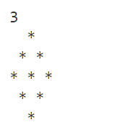

* **Practical- 11: Develop minimum 4 program based on variation in methods i.e., passing by value, passing by reference, returning values and returning objects from methods.**

// Passing by value

import java.util.Scanner;

class CallByValue {

static void swap(int a, int b){

int c = a;

a=b;

b=c;

}

public static void main(String[] args) {

Scanner sc = new Scanner(System.in);

int a = sc.nextInt();

int b = sc.nextInt();

System.out.println("Values before: "+a+", "+b);

swap(a,b);

System.out.println("Values after: "+a+", "+b);

}

}

**> Output:**

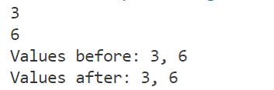

**// Passing By Reference**

import java.util.Scanner;

class Test{

int a, b;

void swap(Test t){

int c = a;

a = b;

b = c;

}

}

public class CallByReference {

public static void main(String[] args) {

Scanner sc = new Scanner(System.in);

Test t = new Test();

t.a = sc.nextInt();

t.b = sc.nextInt();

// t.a = 5;

// t.b = 6;

System.out.println("Values before: "+t.a+", "+t.b);

t.swap(t);

System.out.println("Values after: "+t.a+", "+t.b);

}

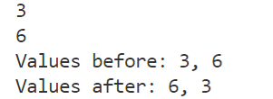}

**// Returning value**

import java.util.Scanner;

class CallByValue {

static void swap(int a, int b){

int c = a;

a=b;

b=c;

}

public static void main(String[] args) {

Scanner sc = new Scanner(System.in);

int a = sc.nextInt();

int b = sc.nextInt();

System.out.println("Values before: "+a+", "+b);

swap(a,b);

System.out.println("Values after: "+a+", "+b);

}

}

**> Output:**



**// Returning Object**

import java.util.Scanner;

class Test{

int a;

Test(int i){

a = i;

}

Test incr(){

Test t = new Test(a + 10);

return t;

}

}

class Main

{

public static void main(String[] args) {

Scanner input = new Scanner(System.in);

int n = input.nextInt();

Test t1 = new Test(n);

Test t2;

t2 = t1.incr();

System.out.println("Value before: "+t1.a);

System.out.println("Value after: "+t2.a);

}

}

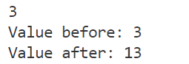

* **Practical- 12: Write a Java Program to find area of Geometric figures using method Overloading.**

// Area of various Geometric Figures using Method Overloading

public class AreaMethOverload{

public static void findArea(int l){

System.out.println("Area of Square is :"+ (l*l));

}

public static void findArea(int l, int b){

System.out.println("Area of Rectangle is :"+ (l*b));

}

public static void findArea(int l, int b, int h){

System.out.println("Area of Trapezoid is :"+ (0.5*(l+b)*h));

}

public static void main(String[] args) {

findArea(5);

findArea(5,6);

findArea(5,6,7);

}

}

**> Output:**

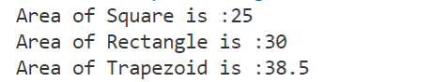

* **Practical- 13: Write a program in Java to create a simple scientific calculator using Math Class.**

// Scientific Calculator using Math Function

import java.util.Scanner;

import java.lang.Math;

public class Calculator {

public static void main(String[] args) {

Scanner sc = new Scanner(System.in);

System.out.println("(+) Addition\n(-) Subtraction\n(*) Multiplication\n(/) Division\n(%) Remainder\n(^) Square\n(s) Square root");

System.out.print("\nEnter your Choice: ");

String n = sc.nextLine();

System.out.print("Enter two numbers: ");

int a = sc.nextInt();

int b = sc.nextInt();

if (n=="+"){

System.out.println("Addition: "+ Math.addExact(a,b));

}

else if (n=="-"){

System.out.println("Subtraction: "+ Math.subtractExact(a,b));

}

else if (n=="*"){

System.out.println("Multiplication: "+ Math.multiplyExact(a,b));

}

else if (n=="/"){

System.out.println("Division: "+ Math.floorDiv(a,b));

}

else if (n=="%"){

System.out.println("Modulus: "+ (a%b));

}

else if (n=="s"){

System.out.println("Square root: "+ (Math.sqrt(a)));

}

else if (n=="^"){

System.out.println("Square root: "+ (Math.pow(a,2)));

}

sc.close();

}

}

**> Output:**

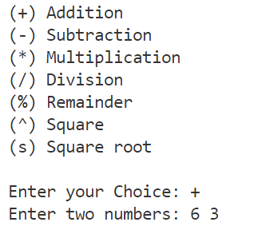



* **Practical- 14: Write a program in Java to sort the elements of list so that they are in ascending order (Take dynamic array).**

// Sorting Array

import java.util.Scanner;

public class SortArray {

public static void main(String[] args) {

int n, temp;

Scanner sc = new Scanner(System.in);

// Taking input of array

System.out.print("Enter no. of elements you want in array: ");

n = sc.nextInt();

int a[] = new int[n];

System.out.println("Enter all the elements:");

for (int i = 0; i < n; i++)

{

a[i] = sc.nextInt();

}

**// Sorting loop**

for (int i = 0; i < n; i++)

{

for (int j = i + 1; j < n; j++)

{

if (a[i] > a[j])

{

temp = a[i];

a[i] = a[j];

a[j] = temp;

}

}

}

**// Printing the array**

System.out.print("Ascending Order: ");

for (int i = 0; i < n - 1; i++)

{

System.out.print(a[i] + ", ");

}

System.out.print(a[n - 1]);

}

}

**> Output:**

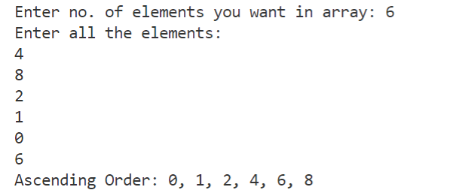

* **Practical- 15: Write a program in Java to multiply two matrixes (Take dynamic arrays).**

// Multiplication of Matrices

import java.util.Arrays;

import java.util.Scanner;

public class MatrixMultiply {

public static void main(String[] args) {

Scanner sc = new Scanner(System.in);

int i,j,k;

**// Taking dimensions of Arrays**

System.out.print("Enter no. of rows of 1st array: ");

int row1 = sc.nextInt();

System.out.print("Enter no. of columns of 1st array: ");

int col1 = sc.nextInt();

System.out.print("Enter no. of rows of 1st array: ");

int row2 = sc.nextInt();

System.out.print("Enter no. of columns of 1st array: ");

int col2 = sc.nextInt();

if (col1==row2){

**// First Array**

System.out.println("\nEnter elements of 1st array");

int a[][] = new int[row1][col1];

for (i=0; i<row1; i++){

for (j=0; j<col1; j++){

System.out.printf("Enter element[%d][%d] : ",i,j);

a[i][j] = sc.nextInt();

}

}

System.out.println("1st Array: "+Arrays.deepToString(a));

**// Second Array**

System.out.println("\nEnter elements of 2nd array");

int b[][] = new int[row2][col2];

for (i=0; i<row2; i++){

for (j=0; j<col2; j++){

System.out.printf("Enter element[%d][%d] : ",i,j);

b[i][j] = sc.nextInt();

}

}

System.out.println("2nd Array: "+Arrays.deepToString(a));

**// Multiplying Array**

int c[][] = new int[row1][col2];

for (i = 0; i < row1; i++) {

for (j = 0; j < col2; j++) {

for (k = 0; k < row2; k++){

c[i][j] += a[i][k] * b[k][j];

}

}

}

System.out.print("\nThe Multiplied array is ");

System.out.println(Arrays.deepToString(c));

}

else{

System.out.println("\nArrays can't be multiplied!!");

}

}

}

**> Output:**

